Grant Assistance for Grass-Roots Human Security Project
Grant Contract Signing Ceremony for
The Project for the Provision of School Bus For Rest Primary and Infant School
The Project for the Provision of School Bus For Bustamante High School
The Project for the Provision of School Bus For Port Antonio Primary School

A triple Grant Contract signing ceremony between our Ambassador Yasuhiro ATSUMI of the Embassy of Japan and Dr. Sandra Smith, the Principal of Rest Primary School Clarendon, Mr. Wayne Evans, Principal of Bustamante High School, Clarendon and Mrs. Kennecha Davis-Williams, Principal of Port Antonio Primary School, Portland was held at the Ministry of Education and Youth on February 5, 2025 under the Grass-Roots Human Security Projects Programme in Jamaica. All three(3) projects will provide a School Bus Transportation at each school for which the amount of $JMD 6.4 Million or USD $42,974.00 will be provided for Rest Primary & Infant School, 11.2 Million Jamaican Dollars or USD$72,238.00 for Bustamante High School and another $11.2 Million Jamaican Dollars or USD$73,088.00 for Port Antonio Primary School.

Ambassador Atsumi noted that Japan is pleased to extend grant assistance in order to alleviate the commuting transportation woes that students in Portland and Clarendon mainly face in addition to absenteeism or impunctuality due to lack of reliable transportation between their homes and the schools. From 2017 to date, the Government of Japan has provided a total of 15 buses (including the 3 (three) buses under 3 (three) separate Agreements just signed) to Jamaican schools islandwide.

Permanent Secretary Troupe announced that the new buses will impact approximately 1,200 students and provide an opportunity to provide equity. In addition, the Education Ministry is making the application for the establishment of Driver posts in the beneficiary schools that with enable each school having a Bus Driver in place being fully remunerated by the Ministry. Dr. Troupe extended gratitude to the Government of Japan on behalf of the beneficiary schools.

Other notable attendees included Permanent Secretary in the Ministry of Education, Dr. Kasan Troupe who represented The Hon. Dana Morris- Dixon, the Minister of Education and Youth, Mrs. Yakeisha Blackwood-Grant, Regional Director – Region 2., Mrs. Delinda Chablal, Vice Chairman, Bustamante High School, Mrs. Paulette Brimm-Smith, Board Chairman Port Antonio Primary School, Mrs. Gabrielle Vaz Black representing East Portland Member of Parliament, Mrs. Ann-Marie Vaz, Mrs. Latoya Harris-Ghartey, Executive Director National Education Trust, Mrs. Keisha Jonson, Director, Donor& Partnership Management, National Education Trust, along with teacher students and other officials from the Ministry of Education and Youth.

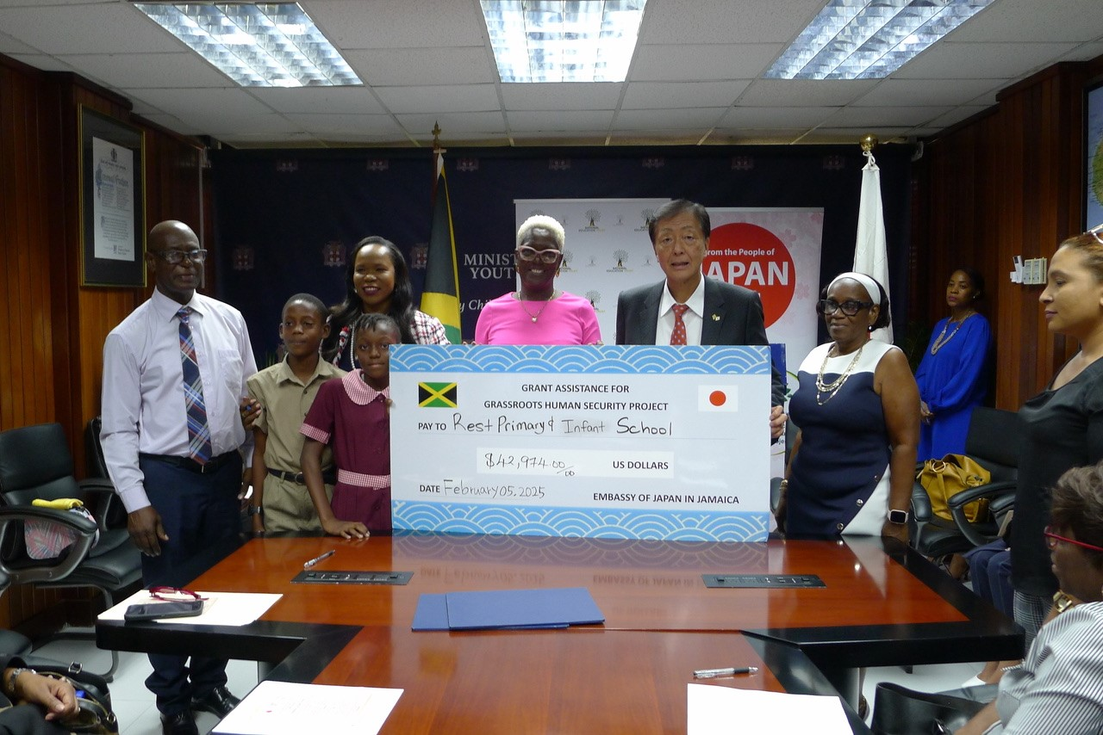

レスト公立小学校

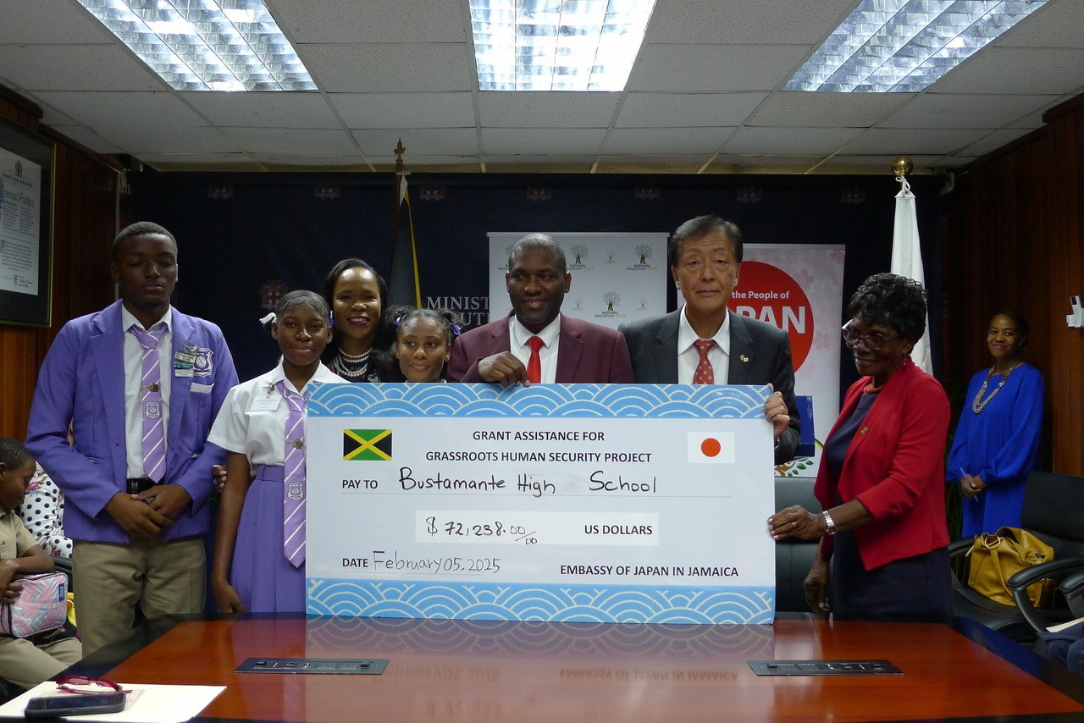

バスタマンテ公立高校
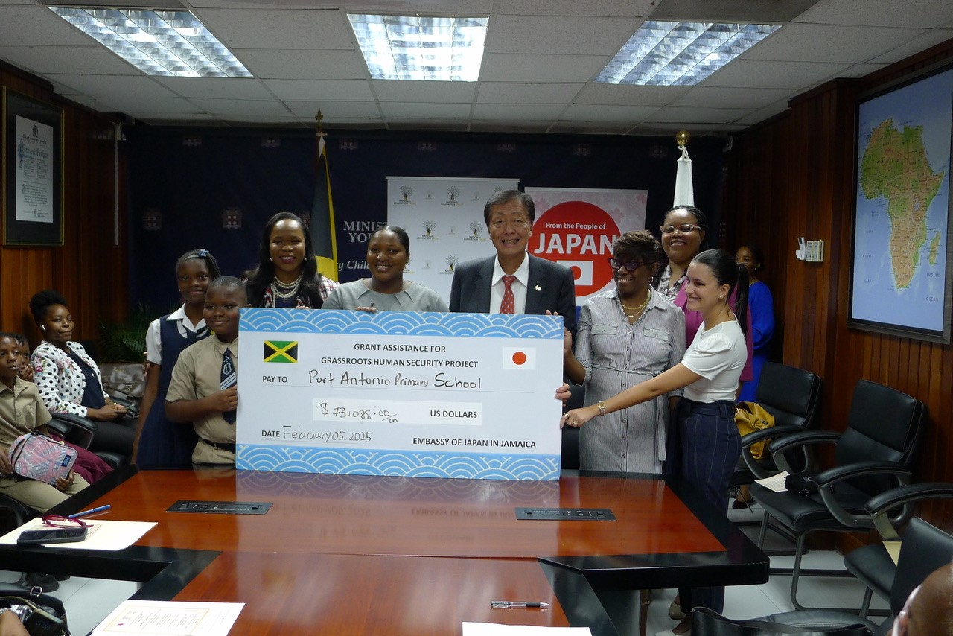

ポートアントニオ公立小学校

